MY PLACE testing – Apple (iPhone/iPad)

To receive an invite please send your Apple ID (the email address you use with Apple services) to [david_rowe@bathnes.gov.uk](mailto:david_rowe@bathnes.gov.uk). It is easiest to use whichever email address is already set up on your iPad/iPhone.

### Find Your Apple ID

If you’re not sure of your Apple ID:

1. On your device **open the Settings app**. You can access this from your Home screen.
2. Tap **iTunes & App Store**. This option is located at the top of the fifth group of options.
3. If you have an Apple ID associated with your device, it will be displayed at the top after Apple ID.

Once we have added you as a tester, you will first receive the first email to that address.

### Email 1

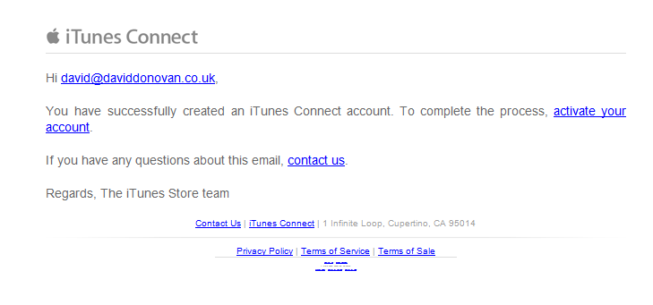

1. Select the ‘*activate your account’* link.
2. This will prompt you to accept an agreement to join iTunes Connect. Once that is done your account should be confirmed. A second email will follow within a couple of days.

### Email 2

### 

**You will need to open the second email on your iPad/iPhone** (the email can be forwarded if necessary).

1. Select the *TestFlight* link within the small print.
2. This will open the App Store, select the ‘**Get’** button to download the TestFlight app.
3. Once that has installed return to the email and select ‘*Start Testing’*. This will launch the app store again, but this time with our ‘**MyPlace’** app. Again, select ‘**Get’** to install the app.